STA 9750 - Software Tools for Analysis (Spring 2024)

Final Report

Members: Monirul Islam, Eric Korshun, Opal Lynch, Charles Ramirez, Jisoo Pak

**U.S Housing Market**

The single-family real estate market in the United States has changed drastically since 2000, influenced by a web of different factors such as population migration, price fluctuations, and social dynamics. As the market continues to evolve, understanding these drivers becomes essential for decision-making. Our analysis aims to provide clear insights into what drives price changes in the single-family real estate market, using data on economic indicators, population estimates, and home prices.

Central to our analysis are key variables such as economic indicators, population estimates, average home prices, and regional disparities in the United States. Economic data referenced from the Regional Data set by the U.S. Bureau of Economic Analysis, and average home prices sourced from Zillow Home Value Index, supported our analysis. By conducting correlation and permutation tests, supported by visualizations, we aim to understand the factors driving price fluctuations in the single-family real estate market.

**Question 1**

The first variable to compare home price fluctuations is population. Population estimates data was retrieved from the U.S. Census Bureau, which was tidied to display estimates from 2000 to 2023 by region. Through their system, the Census Bureau has clustered the states into four separate regions: Northeast, Midwest, South, and West. Home price data was obtained from Zillow, which was tidied to show the average price of a home by region from 2000 to 2023. The two variables, population estimates and home prices by region were then joined together to conduct further analysis.

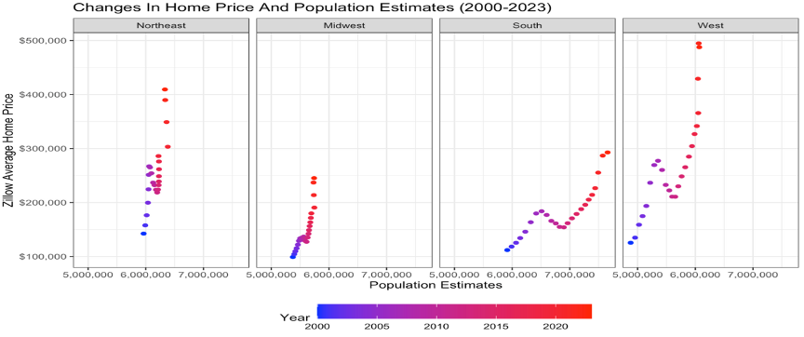

A correlation test between the two variables resulted in approximately 0.22, which means it is a weak relationship, but there is still some degree of influence. According to the visualization above, the South region experiences the most population growth out of all the other regions. The West region is second in population growth but has the fastest acceleration in home value. For more insights, supplementary analysis was done to observe where exactly people were going to in the South and West, and how home prices have changed in those states.

In the South, states like Florida and Texas experienced the most population growth, with Florida experiencing 41 percent growth and Texas experiencing 46 percent growth since 2000. The average home price in Florida has increased 254 percent and in Texas 169 percent. In the District of Columbia, despite a 19 percent population increase, home values have surged 267 percent, which could be accredited to high demand and limited supply of housing, job development, lack of price decline after the housing bust, and other factors. For the West, the population has shifted to states such as Arizona, Idaho, Nevada, Utah, and Washington, with home prices increasing respectively. Two states in particular stand out in the West, California, and Hawaii. In California, despite a 15 percent population increase, home values have escalated 269 percent since 2000 due to a limited supply of housing and scarcity of vacant land. In Hawaii, despite an 18 percent population increase, home prices have catapulted 319 percent since 2000 which is greatly due to Hawaii being a vacation hot spot. There is more demand for rentals, which reduces housing options for residents. Considering all the observations, the variable population itself is not enough to make any concrete conclusions. It must be paired with other variables to determine home price fluctuations.

To roughly gauge the supply and demand of houses, data regarding the sales of single-family homes was acquired. According to the data, the South region had the most sales, which has helped keep prices affordable even with the rampant population growth. Sales were much lower in the Northeast region and the West region, which can be attributed to higher home prices overall.

**Question 2**

To further investigate the changes in real estate prices, additional economic indicators were explored, including personal disposable income and consumer spending. Data on these two indicators was extracted from the Regional Data provided by the U.S. Bureau of Economic Analysis (BEA) and tidied by region from 2000 to 2022.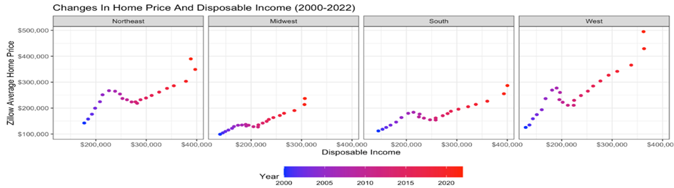

Starting with disposable income, there is a positive, continuous trend across all four regions. A drop-off occurred in home prices around 2008 despite the maintenance of disposable income, which can likely be connected to the economic conditions at the time. Regardless, a strong relationship is evident between the two variables as the correlation test gives a value of approximately 0.72. Several reasons can contribute to this connection. The first reason is consumers' exposure to assets; an increase in disposable income may lead to an increase in buyers’ allocations of funds in the real estate market. A cumulative increase in buying power may lead to an increase in home value. Consumer confidence may also be heightened with increased disposable income as it may be correlated to confidence in the economy, further increasing the demand for purchasing real estate. Similarly, speculation may cause buyers to rush into the real estate market with optimism about future returns.  
 The next indicator to explore alongside home price fluctuations was consumer spending.

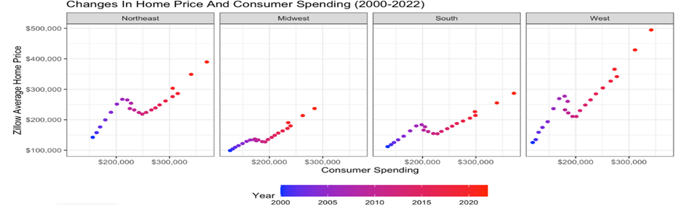

There is a very similar trend to that of home prices and disposable income. A correlation test between consumer spending and home values generated a score of about 0.73, which is a strong relationship. Consumer spending is generally tied to disposable income, confirming the analysis of the previous chart. A reason that can be attributed to this trend is the housing wealth effect, where rising house prices increase homeowners’ perceived wealth, leading them to spend more on consumption. Additionally, relaxed borrowing constraints play a role as higher house prices enable homeowners to borrow more against their home equity to finance their spending. Lastly, factors like income expectations or financial conditions can boost house prices and consumption spending.

**Question 3**

Now we will look at how major events, specifically the 2008 mortgage crisis and COVID-19 affected population dynamics, housing markets, and economic indicators within affected regions. 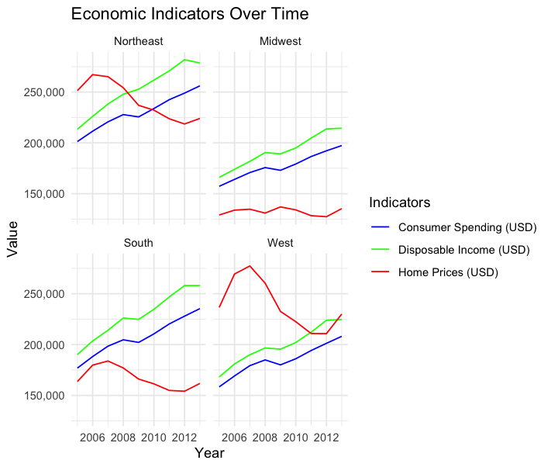

The market plummet began in 2006, with a noticeable decline in housing prices in the Northeast, as evidenced by data from Zillow which showed the steepest price drop during this period. This trend of declining home values spread to other regions, culminating in the West experiencing the most dramatic shifts between 2007 and 2012, where the average home price plummeted 31.6% from a peak in 2007 to its lowest in 2012.

Despite these challenging conditions in the housing market, our analysis reveals a resilience in economic

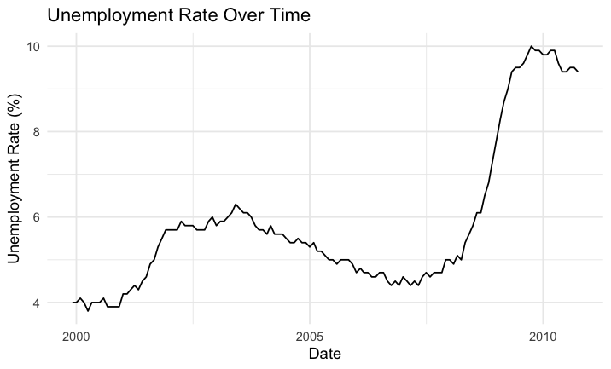

indicators such as disposable income and consumer spending. After the initial shock of the 2008-09 recession, these indicators rebounded significantly.

The correlation between these economic indicators and the housing market is further complicated by employment trends. Employment data showed a downturn at the onset of the crisis, with a steady recovery starting only a few years later. This trend is visually represented in our unemployment rate graphs, which illustrate the spike in unemployment during the crisis, followed by a gradual decrease as the economy recovered.

Interestingly, while other regions struggled, the Midwest experienced a housing market boom in 2009. This anomaly is attributed to the region’s minimal exposure to the housing bubble and its limited dependence on the fluctuating auto industry, as discussed by economist Howard Wial from the Brookings Institute. Our data visualizations of Midwest home prices and employment rates underscore this resilience, showing less volatility compared to other regions.

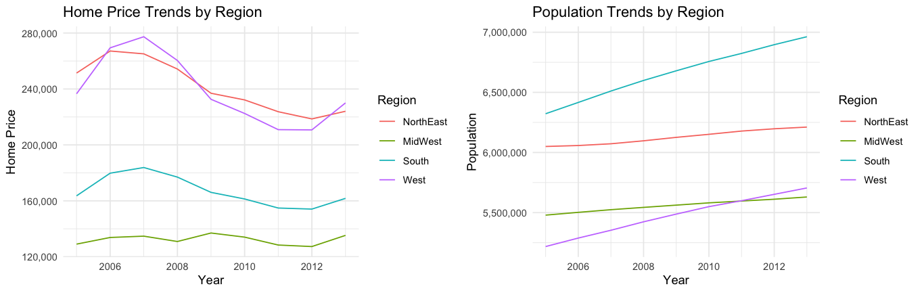

Population trends across all regions also supported this narrative of resilience, with steady increases despite the economic downturn. The visual representation of population growth remains upward trending throughout the crisis years, indicating that demographic dynamics were not significantly deterred by the economic conditions.

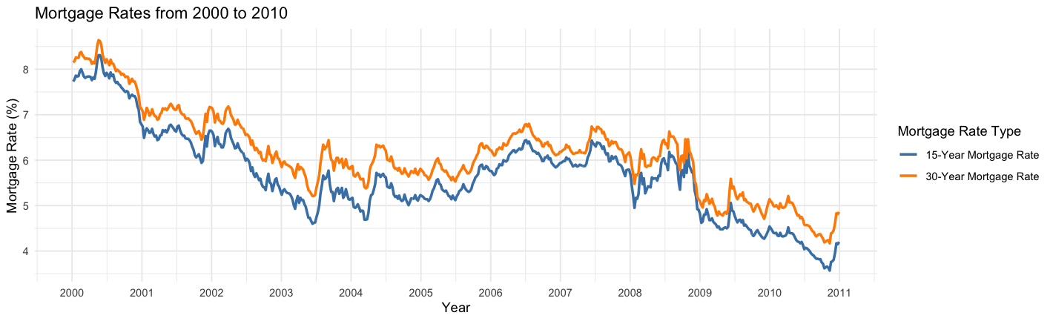

To provide a broader economic context, we also examined mortgage rates, utilizing data on 15-year and 30-year mortgage rates from FRED. The trends in these rates were pivotal, with decreases in mortgage rates generally encouraging buying despite economic hardships, as depicted in our graphs that track mortgage rate changes from 2000 to 2010. These visuals highlight the significant drops in rates post-2008, which helped cushion some of the blows to the housing market.

The onset of the COVID-19 pandemic influenced significant shifts in migration patterns and housing demand across the United States. Analyzing this provides critical insights into the societal response to the pandemic and its lasting effects on residential preferences and economic indicators.

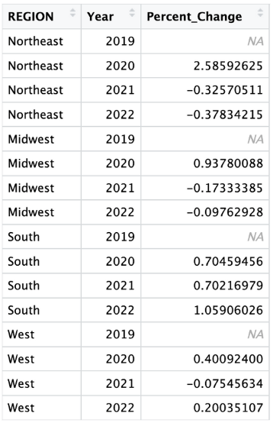

The Northeast region, historically characterized by high population density and urbanization, experienced a notable deviation from migration trends observed in previous years. While typically exhibiting the highest levels of out-migration to other regions, the Northeast saw a departure from this pattern in 2020. This shift can be attributed to several factors, topping among them being the region's status as an early epicenter of the pandemic. The strict quarantine measures and concerns over public health safety likely deterred individuals from relocating, resulting in a stagnant, or decreased, migration trend. Furthermore, the pandemic catalyzed a broader trend of migration away from densely populated urban centers towards suburban and rural areas, driven by a desire for increased space and perceived safety.

In addition, the Southern region experienced a surge in population growth throughout the pandemic. Factors contributing to this trend include the region's comparatively lower cost of living, housing affordability, and desirable lifestyle amenities. The popularity of remote work opportunities further exacerbated this migration, as individuals sought to capitalize on the flexibility to relocate to areas offering greater value and quality of life.

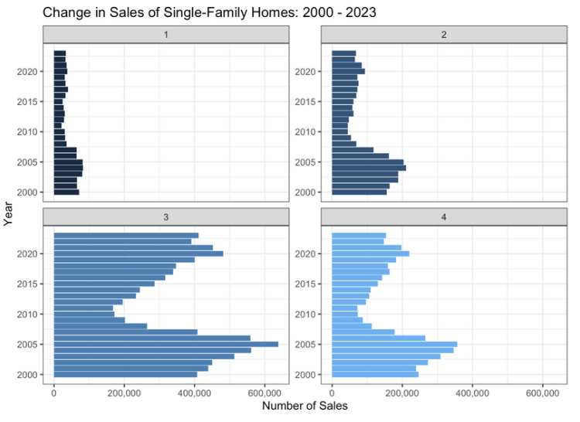

Despite periodic fluctuations, single-family home sales remained robust in these areas, reflecting the demographic influx and preferences for suburban living. In contrast, the Northeast experienced lower levels of single-family home sales, attributed to factors such as high property costs, limited housing supply, and a cultural preference for multifamily dwellings.

**Conclusion**

Our analysis dives into the dynamic landscape of the single-family real estate market in the United States, which has undergone significant transformations since 2000. Through an in-depth analysis of key variables such as economic indicators, population estimates, average home prices, and regional disparities, we have gained valuable insights into the factors driving price changes in this market.

While our analysis uncovers significant trends and relationships in the single-family real estate market, there are many limitations. Our study focuses on aggregate trends, overlooking nuanced dynamics at the local level. Future research could address these limitations by integrating more specific data, like districts or zip codes. Expanding and refining visualizations could increase the statistical understanding to support decision-making. Future work may explore additional factors influencing price fluctuations, such as demographics and environmental considerations, and longitudinal studies could offer insights into market resilience and adaptability, in addition to social livability factors, like schools, shopping centers, and restaurants.